電通二乙微處理器實驗 實驗結報

實驗名稱 | Lab 01 – LED Blink
組別 | 13 | 組員 | 04050865 高健銘
組別 | 13 | 組員 | 03050095 廖偉成

- 實驗目的
透過調整秒數來觀察LED的閃爍狀況，再上傳到GITHUB
- 實驗步驟
首先先選擇pin腳，再選擇電位，在放上led還有電阻再調整秒數來實驗
- 程式碼
/*
Blink
Turns on an LED on for one second, then off for one second, repeatedly.

Most Arduinos have an on-board LED you can control. On the Uno and
Leonardo, it is attached to digital pin 13. If you're unsure what
pin the on-board LED is connected to on your Arduino model, check
the documentation at http://arduino.cc

This example code is in the public domain.

modified 8 May 2014
by Scott Fitzgerald
*/

// the setup function runs once when you press reset or power the board
void setup() {
// initialize digital pin 13 as an output.
pinMode(13, OUTPUT);
}

// the loop function runs over and over again forever
void loop() {
digitalWrite(13, HIGH); // turn the LED on (HIGH is the voltage level)
delay(1000); // wait for a second
digitalWrite(13, LOW); // turn the LED off by making the voltage LOW
delay(1000); // wait for a second
}
- 實驗結果及分析
由1000ms改為500ms時，閃爍時間會減半;再由500ms改為2000ms會閃爍4倍的時間。

- 心得討論
由此次的實驗，因為第一次接觸GITHUB所以花了很多時間再熟悉它，不過我們相信再過幾周就可以變更熟悉，使用軟體速度可以更快。
- 修正電路圖
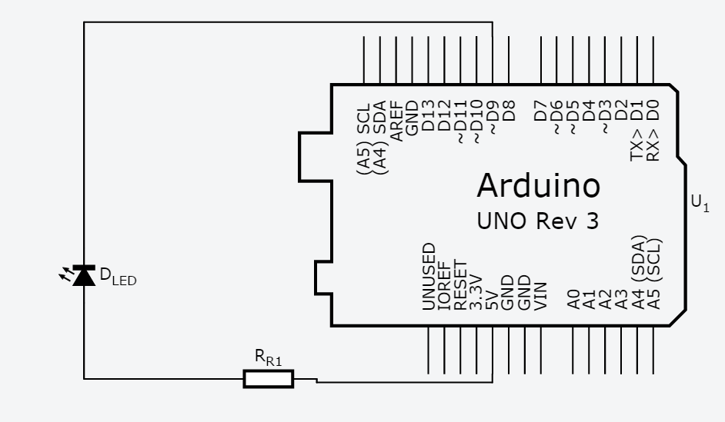
- 修正程式碼
LAB-02
/*
Blink
Turns on an LED on for one second, then off for one second, repeatedly.

Most Arduinos have an on-board LED you can control. On the Uno and
Leonardo, it is attached to digital pin 13. If you're unsure what
pin the on-board LED is connected to on your Arduino model, check
the documentation at http://arduino.cc

This example code is in the public domain.

modified 8 May 2014
by Scott Fitzgerald
*/

// the setup function runs once when you press reset or power the board
void setup() {
// initialize digital pin 13 as an output.
pinMode(9, OUTPUT);
}

// the loop function runs over and over again forever
void loop() {
digitalWrite(9, HIGH); // turn the LED on (HIGH is the voltage level)
delay(500); // wait for a second
digitalWrite(9, LOW); // turn the LED off by making the voltage LOW
delay(500); // wait for a second
}

LAB03
/*
Blink
Turns on an LED on for one second, then off for one second, repeatedly.

Most Arduinos have an on-board LED you can control. On the Uno and
Leonardo, it is attached to digital pin 13. If you're unsure what
pin the on-board LED is connected to on your Arduino model, check
the documentation at http://arduino.cc

This example code is in the public domain.

modified 8 May 2014
by Scott Fitzgerald
*/

// the setup function runs once when you press reset or power the board
void setup() {
// initialize digital pin 13 as an output.
pinMode(9, OUTPUT);
}

// the loop function runs over and over again forever
void loop() {
digitalWrite(9, HIGH); // turn the LED on (HIGH is the voltage level)
delay(2000); // wait for a second
digitalWrite(9, LOW); // turn the LED off by making the voltage LOW
delay(2000); // wait for a second
}

